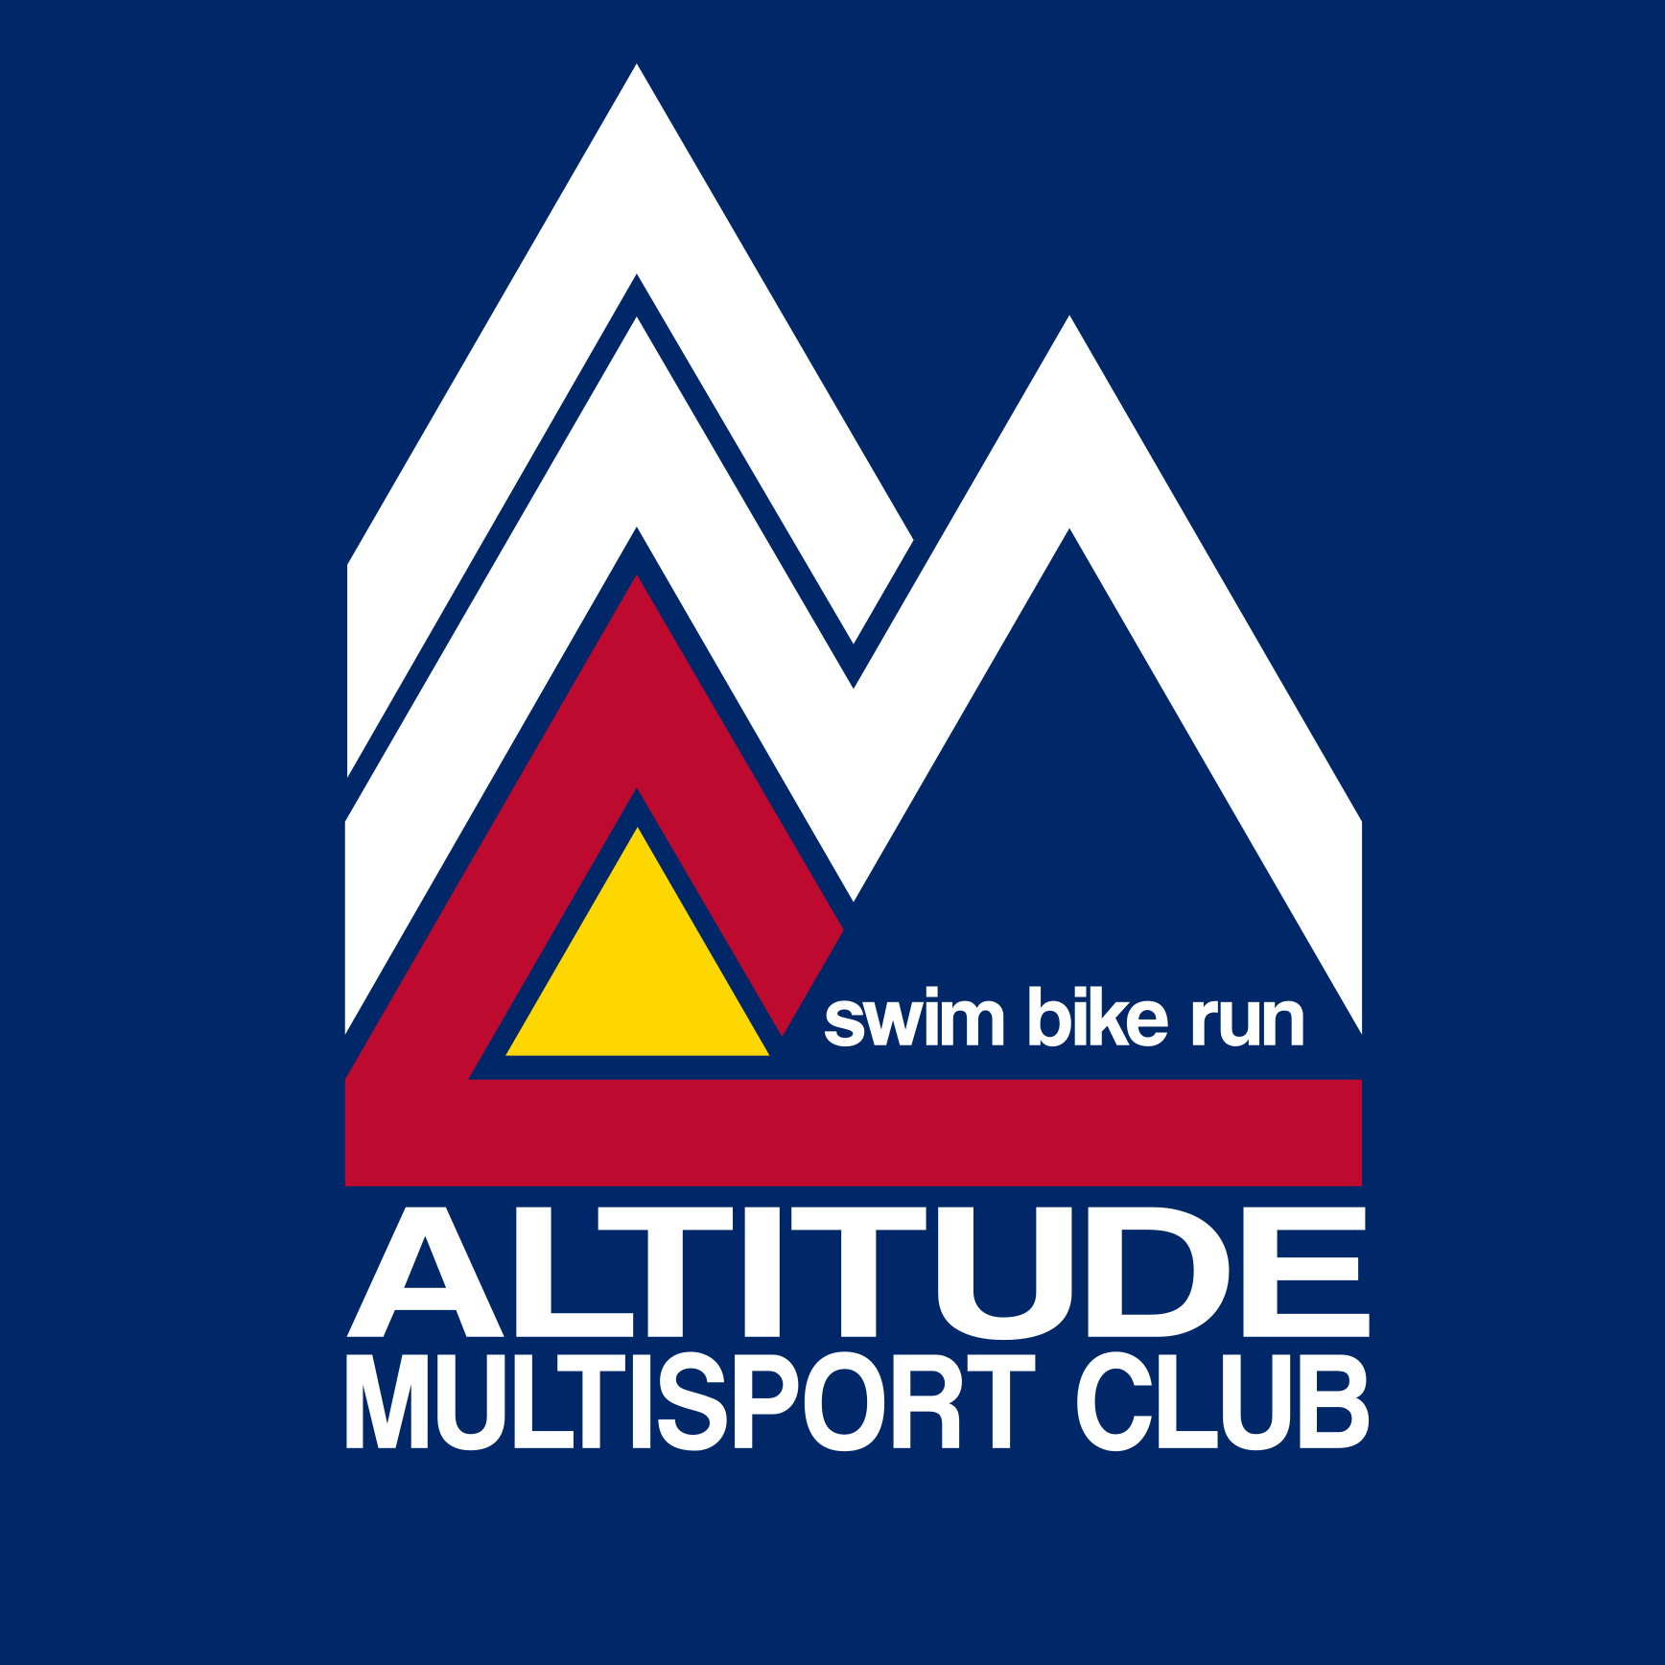

AMC Guidelines for Club Activities
June 01, 2020

All participants must:
- Self-monitor for signs and symptoms of COVID-19 and be clear of these for the previous 14 days
- Wear face coverings over nose and mouth - you must have a face covering (mask/buff) and wear it when we are stopped (i.e. coach briefings).
- Practice social distancing and maintain 6 feet from other members.
- Understand that there may be others on the track/roads/trails that are not affiliated with AMC and maintain distance from them as well.
- Expect some element of risk when participating in group activities with members outside of your household.
- Be considerate and respectful of one another.

Guidelines for club sponsored group practices/clinic:
- Group practices/clinics will be limited to 10 people or fewer. For group rides and runs, if over 10 people, will separate into smaller groups with different start times (i.e. group A starts is faster and starts 5 minutes before group B.
- Track practices will be capped at 9 participants + the coach. Masks or buffs are required when stopped. We strongly recommend that you RSVP via the website.
- AMC will not require that masks/buffs are worn around the nose and mouth while riding/running. However we ask that you pull it up over your mouth and nose while passing someone (i.e. plan on keeping your buff/mask worn around your neck to easily pull up).
- Be self supporting - carry tires, tubes, water, try not to stop at stores.
- Recommend carrying hand sanitizer or wipes.
- Be up front about personal preferences.

